**Professional Practice for Game Development**

**Session 4 Skill and Chance:**

1.0 Background:

My team and I had been given the task of creating a game that takes inspiration from “Noughts and Crosses”. This game should be more catered towards the older demographic and include both skill and chance-based mechanics.

With limited time my team were tasked with designing and implementing a game and game mechanics, meeting with another group to carry out play testing and creating and presenting a PowerPoint of the concept that we had designed and what we had found out.

1.1 The game:

The concept for the game that we had agreed on introduced a card system into the game. These cards provided the chance aspect of the game, where the player could take a risk and receive bonuses or penalties for doing so. On the playing board there would be two decks of cards. The board is a 7x7 grid and the goal is to get as many pieces in a row or in multiple rows. At the start of the game each player gets to place 5 pieces on the board anywhere to get the game started. After the 5 pieces are placed, each turn a player must pick a card from either deck of cards and then take their turn accordingly from what the card they selected says.

One of the decks is called the “risky deck”. The risky deck can either give the player an advantage or cost them the game. Risky Deck is shown in Figure 2.

The card could say “Remove 2 X pieces”, this is because there is never the guaranteed chance that the player will be placing their own piece, adding more risk to the game. A player could draw a place 2 pieces card however it could be the opponents pieces you are placing.

There is also the “Safe Deck” where the risk is lower however the rewards are also lower. The Safe Deck is a 50/50, you either place your own piece or you place your opponents. Safe Deck shown in Figure 1.

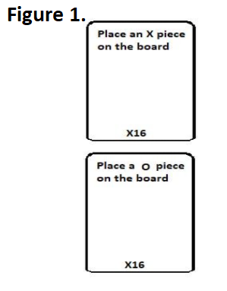

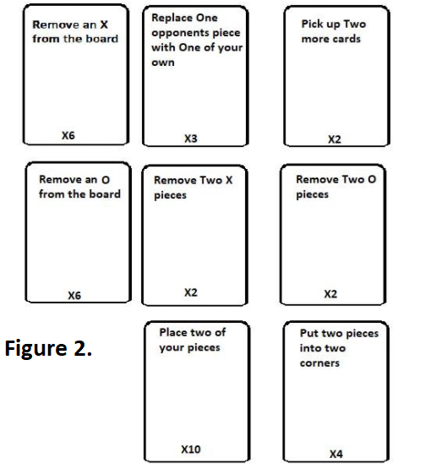

1.2 Materials:

The board that the game would be played on would be made from either wood or plastic. The board will measure approximately 30x30cm and will have a printed design on it for the grid that is played in. On the 30x30 board there will be 4x4cm squares that make up a 7x7 grid. Plastic will also be used to make the play pieces used on the board.

1.3 Rules:

1) You must always draw a card.

2) Do not draw more than 1 card unless you draw a card that tells you to.

3) Once a card has been drawn you cannot swap it for another card in the deck.

4) Once a piece is placed on the board you cannot change its position.

1.4 Playtesting:

Carrying out internal playtesting we found that the game was played too quickly and not many pieces were on the board at the end. From our findings we decided to change the rules slightly so that the players placed 5 pieces to start the game off. We also split the decks into two as we also found that the game was too chance based.   
Playtesting shown in Figure 3.

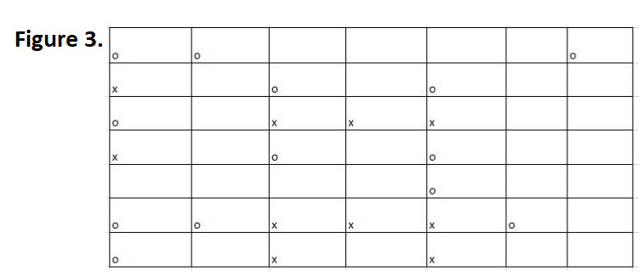

1.5 Conclusion:

I found that the team I was assigned for this task worked well together. We had assigned each other specific tasks to complete rather than all working on one section and having it become a mess. Me and my team shared great communication skills and team working skills.

Reece Taylor, William Connel and Steven